Project Title | Java Online Examination
Project Members | Anuja Nagare, Amruta Morajkar.
Guided By | Mrs.Neepa Shah

System Information

- Problem Definition:

This project gives a brief design for an ONLINE EXAMINATION. Candidates who have registered previously are only eligible for the exam. The login details of a candidate are verified with the records in database. The exam consists of 20 questions each carrying 2 marks. Duration will be 20 minutes. Each question has 4 options. Here candidate will have the liberty to answer questions in a random order. But once a question is selected student has to answer it and the respective question will be locked thereafter.
The candidate has an option to end exam on his choice, else the exam will automatically terminate once the duration is over. This is immediately followed by the display of the result.

- Scope of the Project:

- The application can be used in various computer institutes to test the basics of students on JAVA at intermediate level & DOTNET at a preliminary level
- It can be further modified, enhanced and made suitable for online examinations on other topics.

- Detailed Description:

FRAME ON:

The application begins with the candidate LOGIN. Here the user enters name and enrollment no. On clicking the ‘SUBMIT’ button the user moves on to next frame only if the record is present in the database “DATA” otherwise a message ‘INVALID ENTRY’ is displayed and the user renters the details.

FRAME ON2:

This frame contains the rules for the exam. After reading them user clicks the ‘START’ button to begin.

FRAME ON3:

The user will be provided 20 buttons, each representing a question. On clicking a particular button the corresponding question will appear in a textfield. At the same time its 4 options will be set on the radiobuttons. This data will be retrieved from a database “QUESTIONS”. The user will select the option of his choice and on clicking “SUBMIT ANSWER” button answer selected will be stored in “QUESTIONS”. ‘Answer Selected’ & ‘Correct Answer’ fields will be compared and a ‘Marks’ field in DB will be updated by 2 for every correct answer while for a wrong answer it remains 0.
A user can click on ‘END EXAM’ to quit and get the result. Otherwise the exam will automatically terminate once the timer becomes zero. At such time a message like “TIME UP!” will be displayed followed by the result.

FRAME ON4:

If a user surely wants to quit, may click ‘YES’ button which directly displays the result. Otherwise user may click ‘CANCEL’ button which allows to continue with the exam.

FRAME ON5:

This is is the last frame which contains 2 textfields having labels ‘SCORE’ & ‘RESULT’. The total of the ‘Marks’ column from the DB “QUESTIONS” will give the score of the candidate and is displayed as ‘SCORE’. If the score>20 the result is ‘pass’ else ‘fail’ and the textfield is set respectively.

- Database Design:

  - Data Table:

This table consists of the fields: ‘name’ and ‘enrollmentno’ of students who are going to appear the examination. If the data entered by the user at login is not matching with the details in this table then user cannot proceed further.

NAME | ENROLLMENTNO
ANUJA NAGARE | 1000
AMRUTA MORAJKAR | 1001
SNEHAL JADAV | 1002
SHRADHA SAHARE | 1003
POOJA MEHTA | 1004
NEHA KAUL | 1005
ENZA DESAI | 1006
MANSI THAKKAR | 1007
AMEYA SANGLE | 1008
YASH GARJE | 1009
PRANIT NAGARE | 1010

  - Questions Table:

This table consists of : ‘srno’, ‘questions’, 4 ‘options’, ‘correctanswer’, ‘answerselected’ and ‘marks’ these 9 columns. The question which appears in the textfield as well as the options which appear on radioButtons are retrieved from this table. On clicking ‘SUBMIT’ the answer selected by user is stored in the ‘answerselected’ column. This entry is further compared with the one in ‘correctanswer’ column. For every correct answer ‘marks’ field is updated by 2 else it remains unchanged i.e. 0. Finally at end of exam the sum of ‘marks’ column is calculated and result is displayed in the ‘RESULT’ text field as ‘pass’ if score>20 else ‘fail’.

- Interface Design:

- Interface design of candidate login:
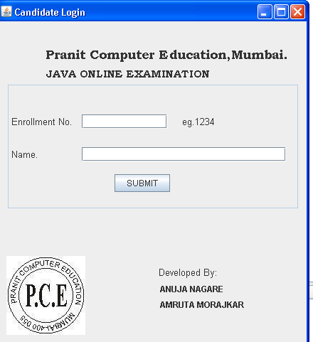

- Interface design of instructions of exam:
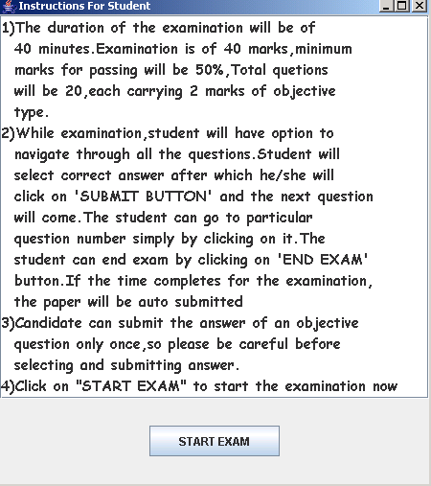
3. Interface design of java online examination:

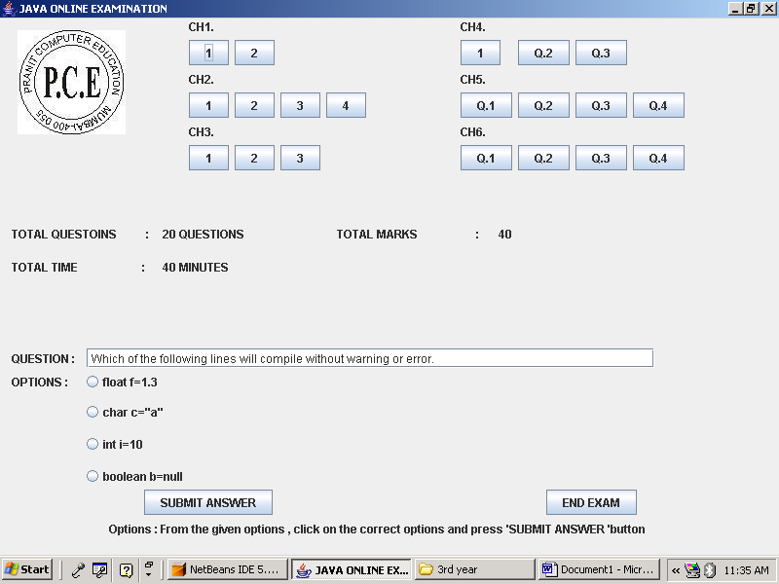

4.Interface design of confirmation:
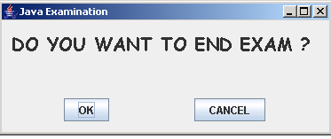

5.Interface design of results:
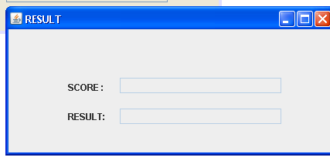

- Development Tools

Software Requirements:

1. Windows Xp
2. Java Development Kit 1.6
3. Java Runtime Environment 1.6
4. Java Virtual Machine
5. Netbeans Ide 5.5.1
6. Microsoft Access

Hardware Requirements:

1. 512 MB Ram (Processor)
2. Mouse
3. Monitor
4. Keyboard
5. 250 MB Free Disk Space

- Future Enhancements:

- This online exam project can be made multi-user applicable and hence conducted over a LAN. Thus, many students can appear the exam at the same time.
- Moreover, in order to make it more effective and competitive the questions should appear in a random order for every student. In case of admissions to reputed UNIVERSITIES the difficulty level can be increased by associating a timer with every question. This helps to evaluate the student in a better way.
- The exam can be made user-friendly by making it suitable in various regional and foreign languages. This would widen the scope of exam.

References:

- Java Certified Professional
- Java complete reference
- http://java.sun.com

